1/28/2016

Simon Light

UTC Reading

Assignment 2

Unit 5

Contents

Introduction 2

P5 - See Faults and Remedies in Appendix. 2

P6 – See PC Logs in Appendix 2

M3 – See PC Logs and Pictures in appendix 2

D2 – Report detailing a network security policy for a small business 2

Part A 2

Firewall management 2

Virus scanning 2

Access control list 2

Passwords 2

Penetration testing 3

Part B 3

Policies 3

Pictures 9

Appendix A – Network Configuration Evidence 9

Appendix B – Routine Maintenance Evidence 17

# Introduction

This report documents the setup of a network which I performed in a group of 7 people including myself. I will be adding an on the day list of faults and fixes and a full write up which was done after the setup was complete. I will be calling to parts of these documents with labels such as “i), ii) etc.”

# P5 - See Faults and Remedies in Appendix.

# P6 – See PC Logs in Appendix

# M3 – See PC Logs and Pictures in appendix

There are explanations and images in the PC logs and pictures. This applies to M3 and P6. The PC logs follow on from the faults and remedies sheet in more detail.

There is also write ups about what is happening in each picture underneath each picture.

# D2 – Report detailing a network security policy for a small business

## Part A

The following is for network managers

### Firewall management

The firewall stops any viruses going into a network/pc. You must be aware of attacks that could be made onto your network. These mainly come in 3 forms; Reconnaissance attack (hacker wants to scout/map network), Access attack (hacker wants to retrieve data), Denial of Service attack (hacker wants to take down/hinder network access). You need to ensure that your firewall is up to date, possibly with weekly updates, to all types of attacks.

### Virus scanning

Virus scanning software/anti-malware software is needed on a network. It also needs to be configured so that the software appropriately deals with the type of malware which was found. The software needs to know that when it finds a virus, it can quarantine, destroy or contact network administrator.

### Access control list

The access control list controls which users can firstly access the network, but also which part of the network. This must be kept up to date. This includes adding users that join the company but more importantly removing users that have left. It is also a good idea to check what kind of access the users have, for example, if a user has 2 computers accessing the network at the same time, it may suggest that the security of their account has been compromised.

### Passwords

It is quite obvious that a password is going to make your computer more secure. You need to be careful with your password and the whole system around it. If it is very easy to reset a password then it removes the purpose of having a password at all.

It is imperative that the password that you use is a strong one. It may be an idea to use a memorable phrase/saying. This is so it is harder to guess and will take a lot longer to crack. Another way is to use a key/pad. This is so you have basic passwords that you then ‘encrypt’ with your pad. A password that was “I’m at work” could become “!M @ M0rI<”. It is an easy to remember pad with a very simple (therefore easy to remember) password.

### Penetration testing

A generally good idea for any new or established network is to look into penetration testing. This is where you employ a penetration tester to try and exploit your network. They will then create a report of your network to suggest ways to improve the security of the network.

It is important to keep your network up to date as technology advances. It should be scheduled on a regular basis. You could just ask a tester to come in and meet with you to tell you common errors of a network however it will not be specific to your network and may cause a lack of security.

## Part B

The following is for network users.

### Policies

All users should adhere to the following policies or risk disciplinary action.

1. Any device that needs to be connected to the network *must* be reviewed by a network manager to check compatibility and security.
2. All devices must be password protected. This must be done with a password of minimum 8 characters, 1 upper case, 1 lower case, 1 special character. This must be updated at least every 6 weeks and passwords cannot be reused.
3. Users must not share passwords with any individual within or out of the business. This includes network administrators.
4. Users should have 2 minute screen savers on their computers and be prompted for a password from wake from sleep.
5. Users should not leave computers unlocked.
6. Antivirus must be on all devices and kept up to date.
7. Any read/write drives must be scanned for viruses/malware upon insertion.
8. All OS’s must have auto update and daily install. Commonly used software should have the same.
9. Users must not connect to non-work specific websites unless they have specific permission from network administrators.
10. Users must not try to remove/avoid any filtering or website blocking.
11. All computers must require a password to access BIOS.
12. All critical data should be backed up at least weekly. This should use a father, grandfather, great grandfather system. See network administrators for advice.
13. On decommissioning of a system, all hard drives must be wiped and destroyed.
14. No other networks should be contacted. This includes “hot spots”.
15. Confidential files should be password protected. This should follow policy 2.
16. No data should be disclosed to anyone outside of the business.
17. All security breaches should be reported and a ticket issued. You should take as much evidence of the breach as possible and submit it to administrators via direct connect (not email). On notice of the breach you should:
    1. Remove device from the network
    2. Perform an full antivirus scan
    3. Note down any error messages

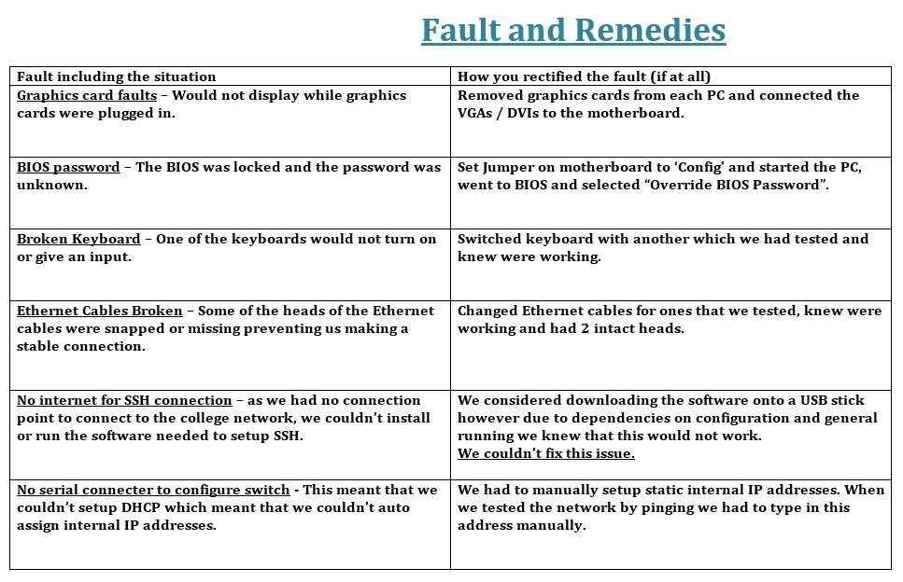Appendix

**PC Log 1**

|  |  |  |  |
| --- | --- | --- | --- |
| **PC ID (on side of tower)** | **001** | **002** | **003** |
| **Hard Drive Capacity** | **500GB** | **500GB** | **500GB** |
| **RAM** | **8GB** | **8GB** | **8GB** |
| **Operating System** | **Ubuntu 12.04** | **Ubuntu 12.04** | **Ubuntu 12.04** |
| **Other installed applications** | **Unknown** | **Unknown** | **Unknown** |
|  |  |  |
|  |  |  |
|  |  |  |
|  |  |  |
| **Display type** | **LCD Monitor** | **LCD Monitor** | **None(SSH connection)** |
| **Components to add to existing configuration** |  |  |  |
|  |  |  |
|  |  |  |

**Network Configuration (including where this asset is in this configuration)**

|  |
| --- |
| **001**  **Switch**  **002**  **003** |

**Issues (detail any issues with the hardware and/or software in this configuration)**

1. Graphics would not display anything on the monitor when VGA/DVI was connected to the dedicated graphics ports.
2. When trying to reorder the boot menu we found that the BIOS was locked with a password that nobody knew.
3. When trying to access by pressing the F10 key we found that one of the keyboards wasn’t working

**How issues were rectified and if not why**

1. Firstly we tried another port on the computer (the one directly from the motherboard). As this displayed we knew that the fault was somewhere in the GPU or between the GPU and monitor. We then decided to remove all GPUs from the computers as they were not needed and we didn’t feel that it was a good use of our time to diagnose a problem that we already had an easy and viable fix for.
2. We found a diagram of the motherboard on the back of the case of the PC. From this we located a jumper switch and set it to ‘Config’ mode. We then started the BIOS, navigated to the ‘Security’ tab and selected ‘Delete BIOS password’. We then turned off the computer, set the jumper back to ‘Normal’ and started the computer which we could now reorder the boot menu on.
3. We found that the keyboard was faulty by trying the ‘Caps Lock’ key. When we pressed it we expected the light up the top right corner of the key to light up. As this didn’t happen we knew that then keyboard either had no power (from a faulty USB port or cable). We next tried a different port on the PC that we knew worked (as we had previously tried to charge a device off of the port). As the keyboard still didn’t work we knew that the keyboard itself was the fault. We then tried a keyboard on another PC and assured it worked, we then placed it into the PC and tested.

**Software/Hardware needed to complete (if required)**

Keyboard to fix problem 3.

**PC Log 1**

|  |  |  |  |
| --- | --- | --- | --- |
| **PC ID (on side of tower)** | **001** | **002** | **003** |
| **Hard Drive Capacity** | **500GB** | **500GB** | **500GB** |
| **RAM** | **8GB** | **8GB** | **8GB** |
| **Operating System** | **Ubuntu 12.04** | **Ubuntu 12.04** | **Ubuntu 12.04** |
| **Other installed applications** | **None** | **None** | **None** |
|  |  |  |
|  |  |  |
|  |  |  |
|  |  |  |
| **Display type** | **LCD Monitor** | **LCD Monitor** | **None(SSH connection)** |
| **Components to add to existing configuration** |  |  |  |
|  |  |  |
|  |  |  |

**Network Configuration (including where this asset is in this configuration)**

|  |
| --- |
| **001**  **Switch**  **002**  **003** |

**Issues (detail any issues with the hardware and/or software in this configuration)**

1. Some of the connections on the Ethernet cables were snapped which meant that we could not create a stable connection.
2. As we had 2 monitors but 3 computers we wanted to connect to the last computer via SSH. As there was nowhere to connect the switch to the college network we couldn’t install or run the software needed to do this.
3. We couldn’t find a serial port adapter to set up DHCP on the switch.

**How issues were rectified and if not why**

1. We replaced all the Ethernet cables one at a time with ones that we had previously tested and knew were working. This allowed us to survey full health of the network and identify any other errors in the network close up.
2. There unfortunately wasn’t a viable fix for this issue. There simply wasn’t any ports near to the switch and we couldn’t connect wirelessly due to the lack of a router and converters. We considered moving the network but it wasn’t viable to do in the timescale that we had. We also had the idea of installing the software onto a USB stick but we realised that we needed internet connections to properly install, configure and run the software on the PCs.
3. We set all of the internal IP addresses of the computers to static addresses and set them to something that was easy to remember (192.168.0.50, 51, and 52). When we did this as when it came to testing the network/pinging we had to manually type in the command “ping 192.168.0.51” depending on which computer we were pinging.

**Software/Hardware needed to complete (if required)**

1. Spare Ethernet cables
2. Ubuntu’s inbuilt network settings.

# Pictures

# Appendix A – Network Configuration Evidence

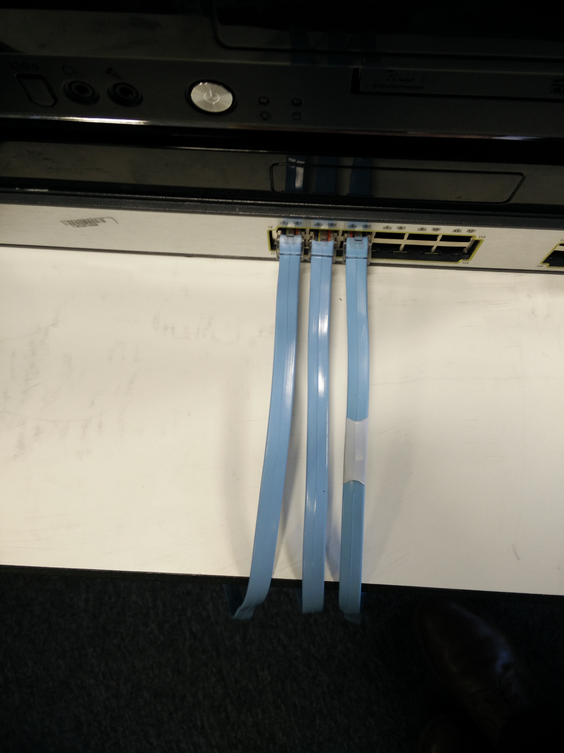

Switch with original cables (these turned out to be faulty)

After installing OS’s onto all of the machines we connected all of them to the switch. When we found that they were not communicating we then discovered that some of the Ethernet cables had broken connecters. After replacing the broken cables we had a working network.

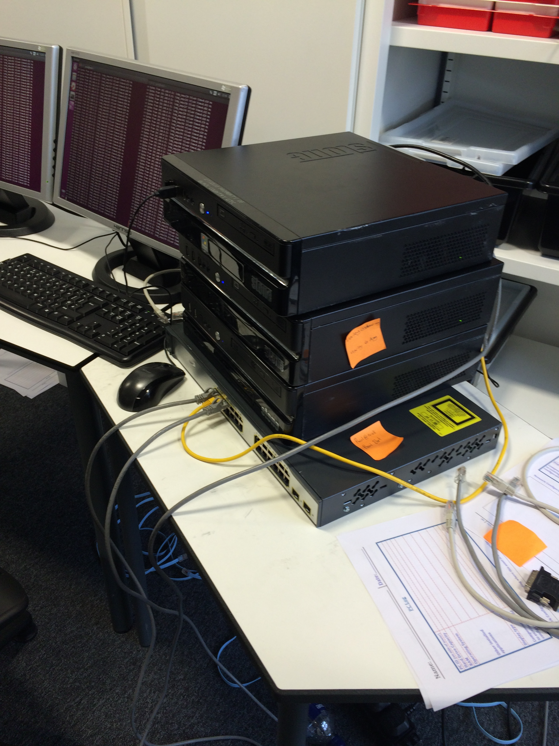

Replaced Ethernet Cables

After installing OS’s onto all of the machines we connected all of them to the switch. When we found that they were not communicating we then discovered that some of the Ethernet cables had broken connecters. After replacing the broken cables we had a working network.

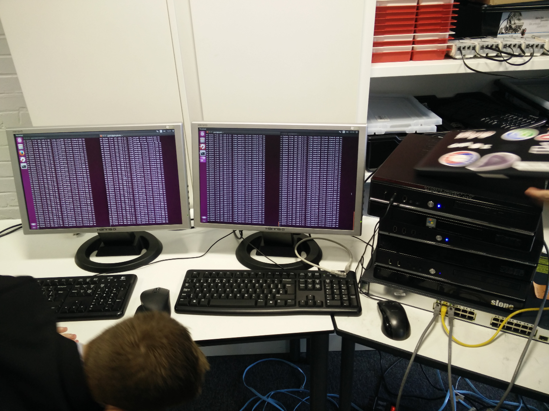

Machines “pinging”

Once we connected the network through the switch we tried to ping from one computer by typing “ping” and then the local address of the computer we wanted to ping into the terminal. We then received a “Connection timed out” error. On inspection of the network we discovered that some of the Ethernet cables were faulty. After replacing these cables, we then tried to ping again. This worked successfully and shown above is proof of all computers communicating across the network.

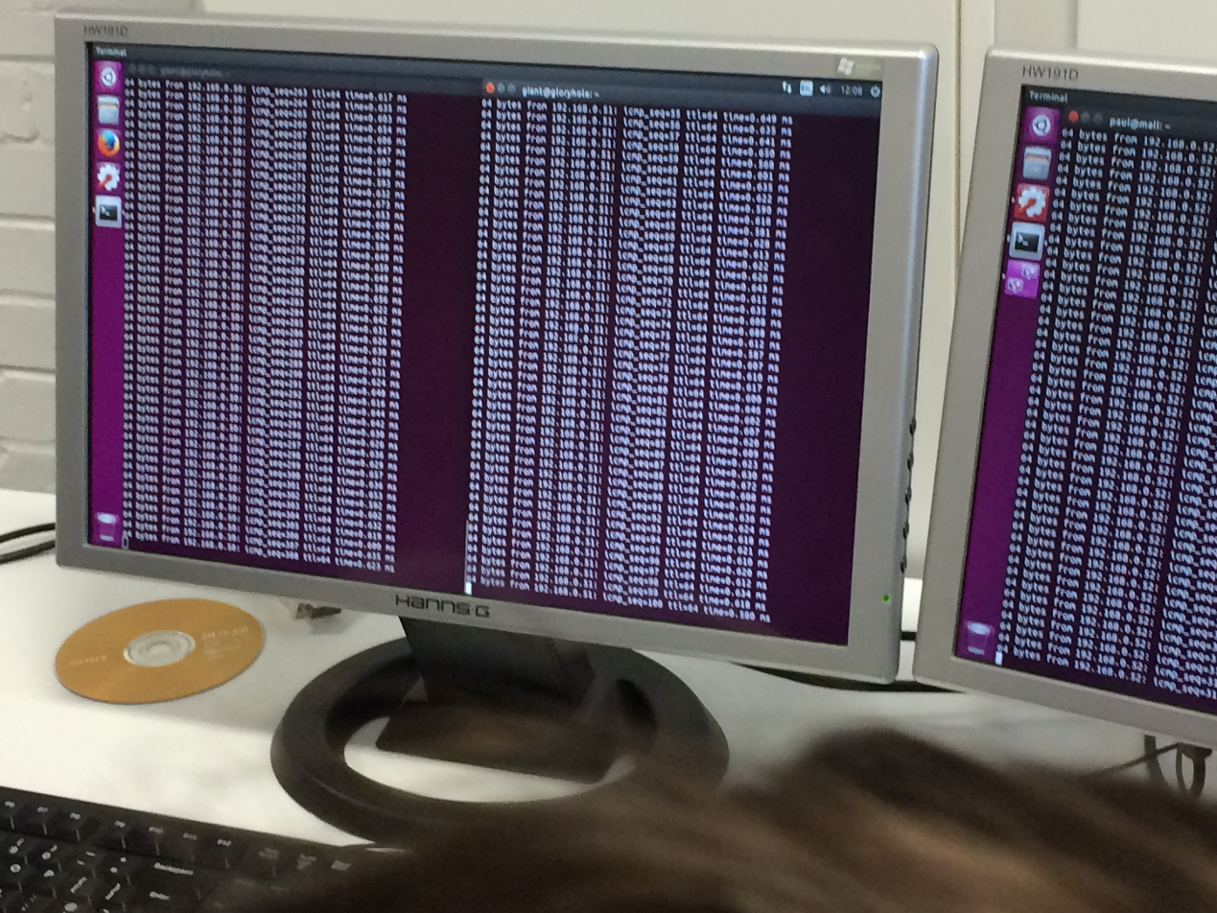

Machines “pinging”

Once we connected the network through the switch we tried to ping from one computer by typing “ping” and then the local address of the computer we wanted to ping into the terminal. We then received a “Connection timed out” error. On inspection of the network we discovered that some of the Ethernet cables were faulty. After replacing these cables, we then tried to ping again. This worked successfully and shown above is proof of all computers communicating across the network.

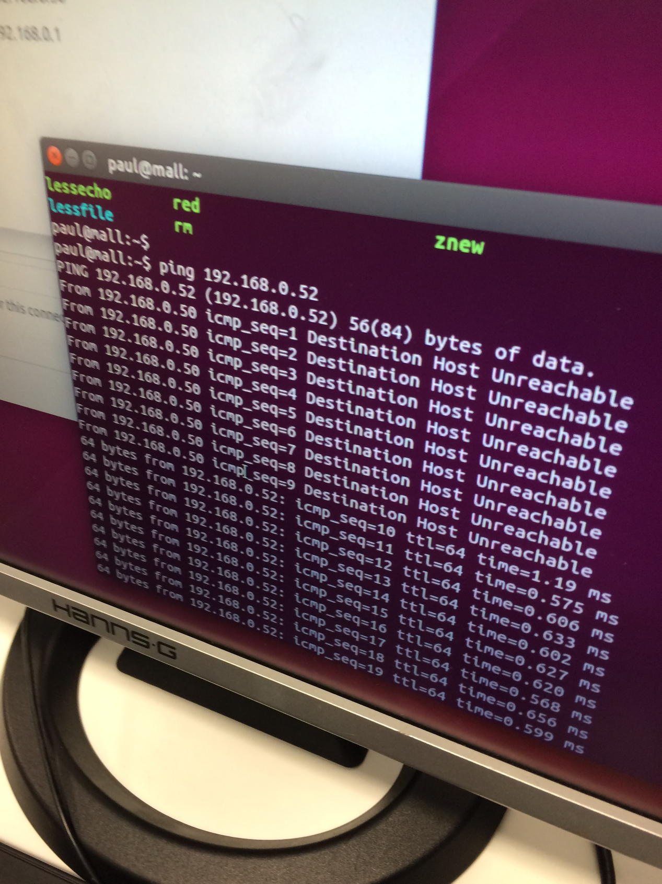

Machines “pinging”

Once we connected the network through the switch we tried to ping from one computer by typing “ping” and then the local address of the computer we wanted to ping into the terminal. We then received a “Connection timed out” error. On inspection of the network we discovered that some of the Ethernet cables were faulty. After replacing these cables, we then tried to ping again. This worked successfully and shown above is proof of all computers communicating across the network.

This point shows one of the errors we got: “Destination Host Unreachable” where we had unplugged the Ethernet cable from the switch, and then successful pings when we plugged it in.

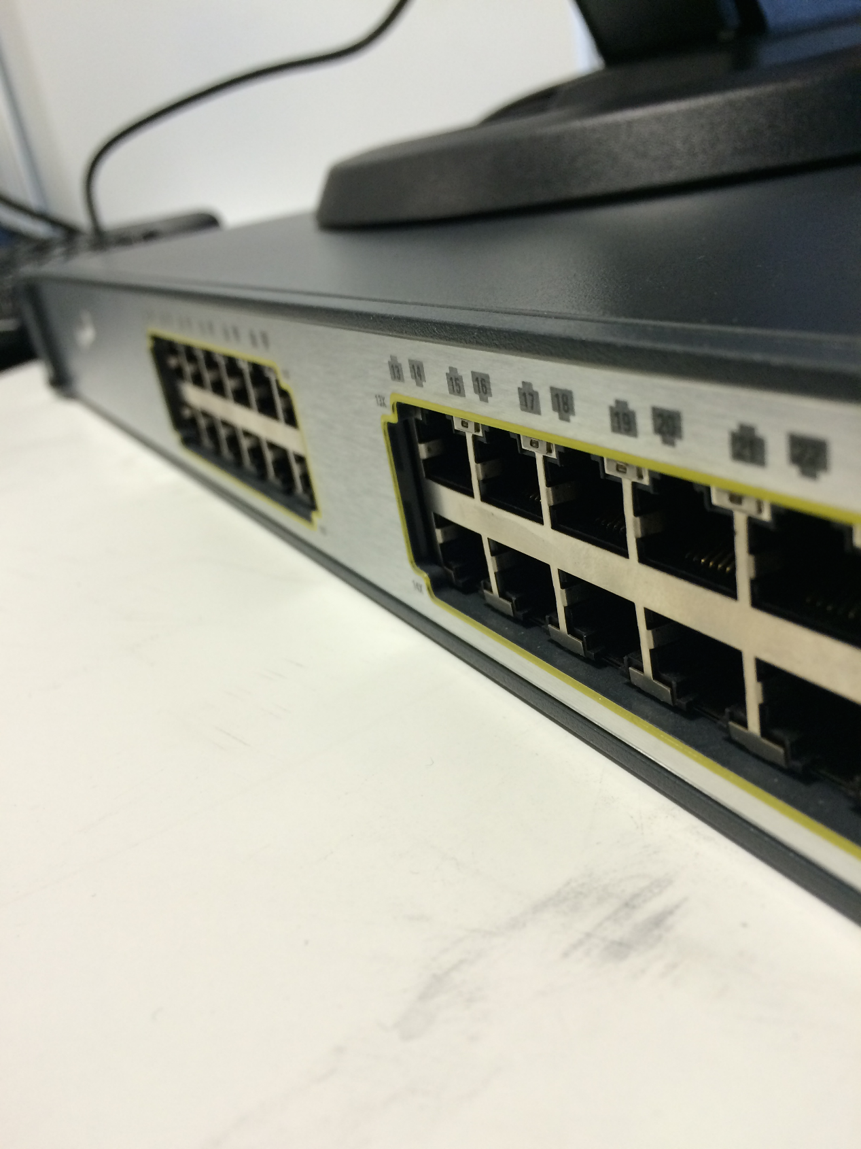

The network switch

This is the switch where we plugged in all computers via Ethernet. We would also plug Ethernet from a central network (i.e. the colleges local network) here to provide internet access for all computers.

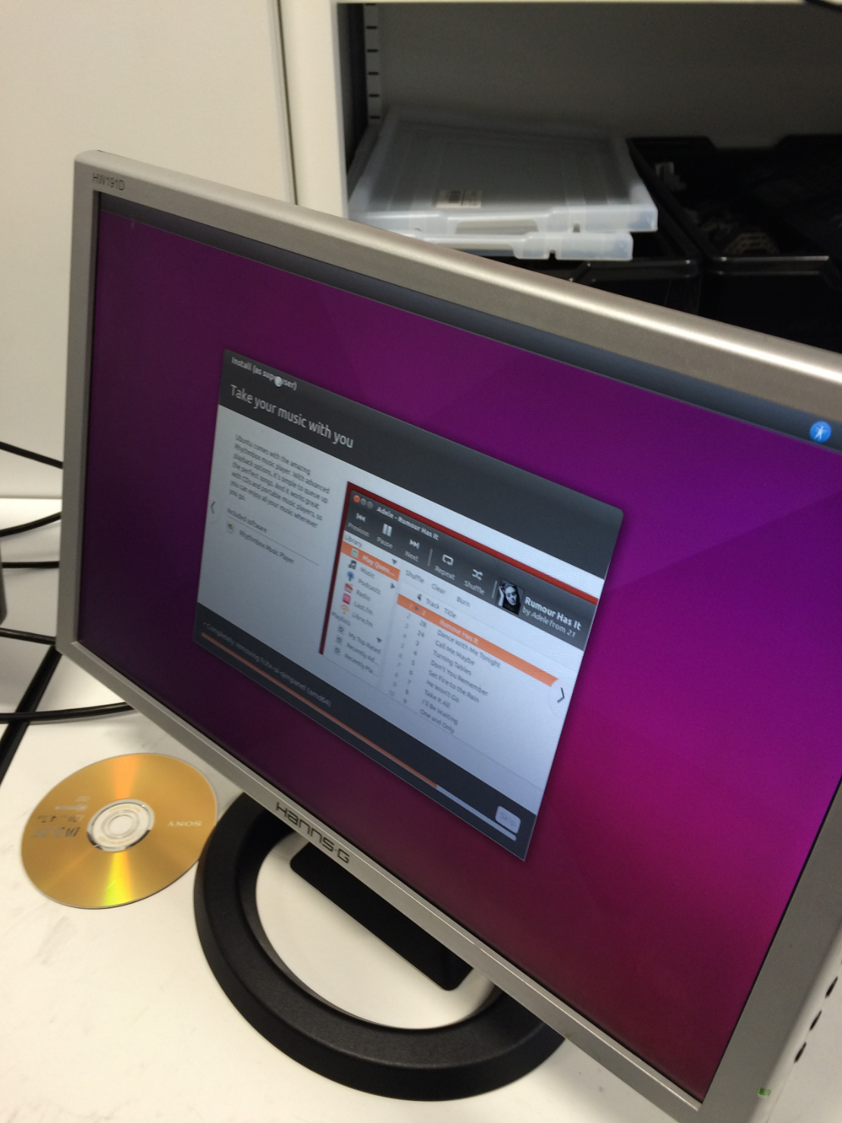

Ubuntu 15.10 Install

We found that when we booted the computers initially they had an old version of a Linux based OS. We needed to write over this by booting from a bootable USB stick that we had created. When we tried to access the BIOS for the boot menu we realised that it was locked with a password. We then proceeded to reset this by changing a jumper on the motherboard to reset the BIOS chip. Once this was done we changed the boot menu so that it would boot from a USB and continued to install the latest version of Ubuntu. When it came to input information (e.g. computer name, user name) we discovered that one of the keyboards wasn’t working. (We found this by pressing the ‘Caps Lock’ key and checking if the light lit up). We then replaced the keyboard and finished the install.

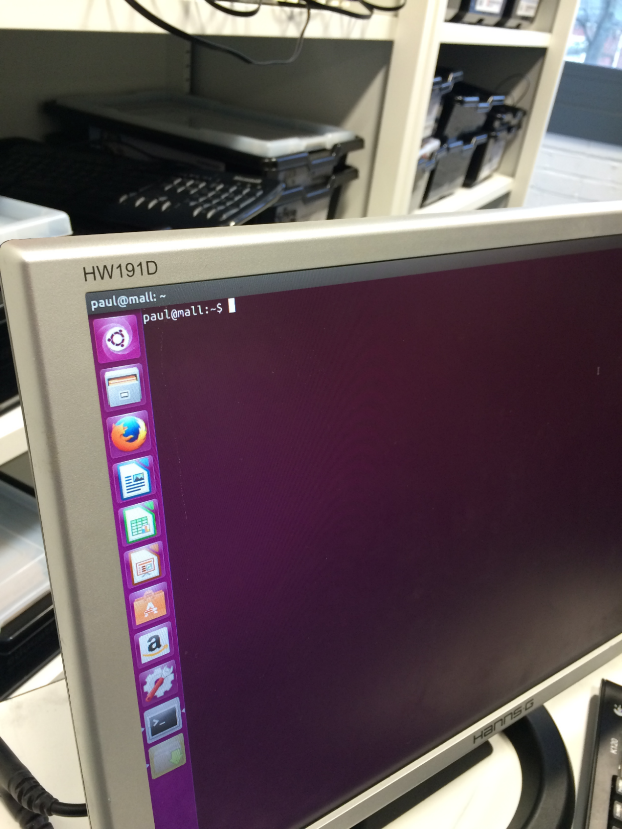

Machine configured with Ubuntu 15.10

We found that when we booted the computers initially they had an old version of a Linux based OS. We needed to write over this by booting from a bootable USB stick that we had created. When we tried to access the BIOS for the boot menu we realised that it was locked with a password. We then proceeded to reset this by changing a jumper on the motherboard to reset the BIOS chip. Once this was done we changed the boot menu so that it would boot from a USB and continued to install the latest version of Ubuntu. When it came to input information (e.g. computer name, user name) we discovered that one of the keyboards wasn’t working. (We found this by pressing the ‘Caps Lock’ key and checking if the light lit up). We then replaced the keyboard and finished the install.

# Appendix B – Routine Maintenance Evidence

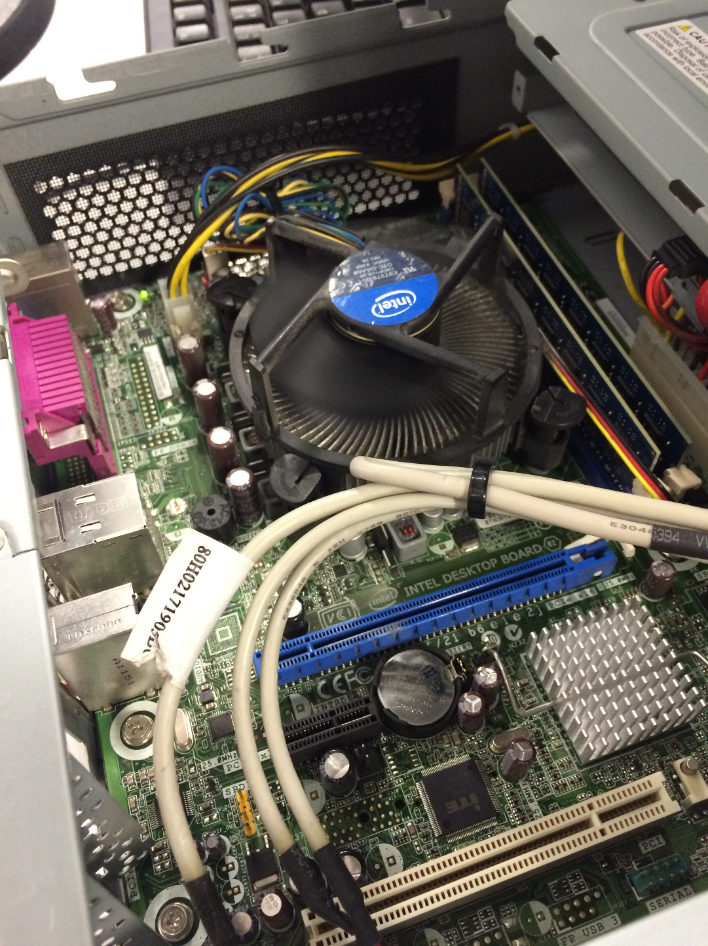

After removing additional graphics card. CMOS battery also visible.

When first booting the PC’s they would not display. We then discovered that they had graphics cards and that these might be a possible point of failure. We then tried the integrated graphics ports and the computer displayed fine. We then removed the graphics cards from all of the computers and connected the displays to the motherboards VGA.

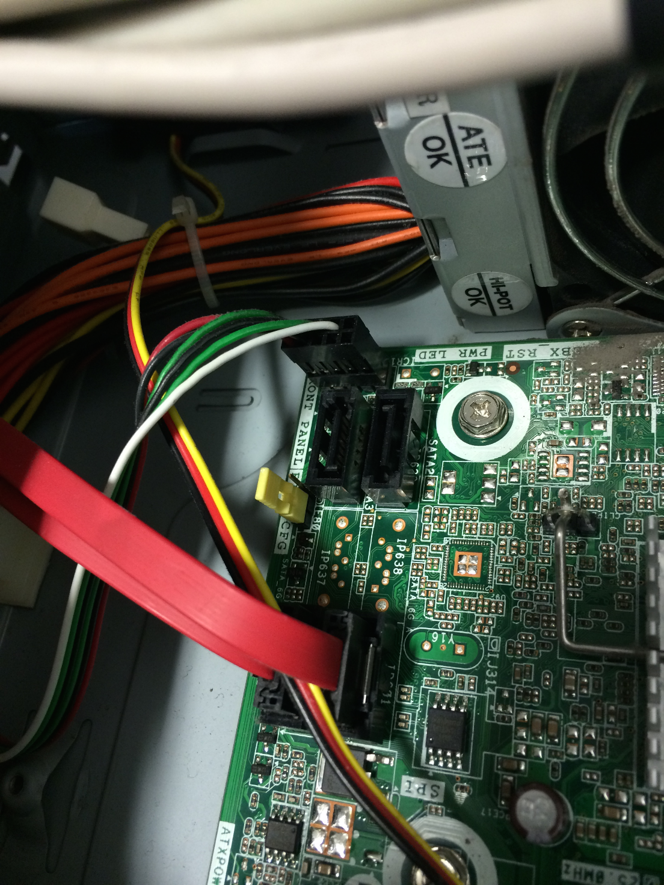

The Yellow Jumper was changed to reset the BIOS

We found that when we booted the computers initially they had an old version of a Linux based OS. We needed to write over this by booting from a bootable USB stick that we had created. When we tried to access the BIOS for the boot menu we realised that it was locked with a password. We then proceeded to reset this by changing a jumper on the motherboard to reset the BIOS chip. Once this was done we changed the boot menu so that it would boot from a USB and continued to install the latest version of Ubuntu. When it came to input information (e.g. computer name, user name) we discovered that one of the keyboards wasn’t working. (We found this by pressing the ‘Caps Lock’ key and checking if the light lit up). We then replaced the keyboard and finished the install.